TABLE OF CONTENTS
1. Introduction
1.1 Background of the Study
1.2 Problem Statement
1.3 Aim and Objectives
2. Proposed System
2.1 System Users
2.2 Main Features
3. Computational Thinking
4. System Algorithms
5. Pseudocode
6. Flowchart Designs
7. System Modules and Functions
8. Variables, Data Types and Control Structures
9. Expected System Outputs
10. GitHub and Open-Source Software
11. Digital Public Goods and SDG Alignment
12. Conclusion
13. References

1. INTRODUCTION

1.1 Background of the Study
Waste management is one of the important environmental challenges affecting many communities in Sierra Leone, particularly in Freetown. The proper collection, transportation and disposal of waste are necessary for maintaining clean surroundings and protecting public health. However, some communities experience problems such as irregular waste collection, improper disposal of rubbish, blocked drainage systems and environmental pollution. These problems can make neighbourhoods unhealthy and affect the quality of life of residents.
In many situations, residents may find it difficult to report waste problems or communicate directly with the people responsible for waste collection. Manual reporting and communication can also result in delays, missing information and poor coordination between residents, administrators and collection teams. As technology continues to develop, digital solutions can provide better ways of managing these activities.
The proposed Smart Waste Management System (SWMS) is designed to provide a more organized and efficient approach to waste reporting and collection management. The system will allow residents to submit reports about waste problems by providing information such as their location, waste category and a short description of the problem. Administrators will be able to review submitted reports, verify the information and assign suitable waste collection teams. Collection teams will then be able to update the progress of their assigned tasks.
This project focuses on using basic programming concepts, computational thinking, algorithms, pseudocode and flowcharts to design a possible solution to a real-world problem in Freetown. Although the proposed system is not being developed as a fully working application in this assignment, its logical design explains how the system would operate and how its different components would work together.

1.2 Problem Statement
Poor waste management can create serious environmental and public health challenges in communities. When waste is not collected regularly, it may accumulate in public areas, residential surroundings and drainage systems. This can contribute to pollution, unpleasant surroundings and conditions that may encourage the spread of diseases.
One of the challenges is the difficulty of reporting waste problems and monitoring whether the reported issues have been addressed. Traditional communication methods may not provide a reliable way to record reports, assign collection teams and track the progress of waste collection activities.
Therefore, there is a need for a simple digital system that improves communication, reporting and coordination between residents, administrators and waste collection teams. The Smart Waste Management System is proposed to address these challenges by providing a centralized method for submitting, verifying, assigning and tracking waste reports.

1.3 Aim and Objectives
The main aim of this project is to design a Smart Waste Management System that improves waste reporting, monitoring and collection coordination in Freetown, Sierra Leone.
The specific objectives are to:
- Provide residents with a simple way to report waste management problems.
- Allow users to submit important information, including location, waste category and problem description.
- Generate unique reference numbers for submitted reports.
- Allow administrators to review and verify waste reports.
- Enable administrators to assign verified reports to suitable collection teams.
- Allow collection teams to update the progress of their assigned tasks.
- Provide a way for residents and administrators to track the status of submitted reports.

2. PROPOSED SYSTEM
SWMS connects residents, administrators and waste collection teams. A resident submits a report; an administrator checks it and assigns a team; the team collects the waste and updates the status.

2.1 System Users
User | Responsibility
Residents | Submit waste reports and check progress.
Administrators | Verify reports, assign teams and monitor records.
Collection teams | View assigned tasks and update collection status.

2.2 Main Features
- User login and role selection.
- Waste reporting with location and description.
- Report verification and team assignment.
- Collection status updates.
- Report tracking and summary reports.

3. COMPUTATIONAL THINKING
Concept | Application in SWMS
Decomposition | Divide the system into reporting, verification, assignment and tracking.
Pattern recognition | Group reports by location or waste category.
Abstraction | Collect only the information needed to process a report.
Algorithm design | Use step-by-step instructions for each process.

4. SYSTEM ALGORITHMS

4.1 Resident Reporting
- Start and open the reporting form.
- Enter name, location, waste category and description.
- Check required details.
- If information is missing, request correction.
- Otherwise, generate a report ID and save as Pending.
- Display confirmation and end.

4.2 Administrator Verification
- Administrator logs in and details are validated.
- Retrieve submitted reports.
- Review each report and approve or reject it.
- Assign a collection team to approved reports.
- Save the decision and update status.

4.3 Collection Team Update
- Team member logs in and views assigned tasks.
- Select a task and set status to In Progress.
- Complete the collection activity.
- Set status to Completed and save.

5. PSEUDOCODE

5.1 Main System
BEGIN
DISPLAY "SMART WASTE MANAGEMENT SYSTEM"
DISPLAY "1. Resident"
DISPLAY "2. Administrator"
DISPLAY "3. Collection Team"
DISPLAY "4. Exit"

INPUT choice
IF choice = 1 THEN
CALL Resident_Module

ELSE IF choice = 2 THEN
CALL Administrator_Module
ELSE IF choice = 3 THEN
CALL Collection_Module
ELSE IF choice = 4 THEN
DISPLAY "Thank you for using the system"

ELSE
DISPLAY "Invalid choice"
END IF

END
END

5.2 Waste Reporting

BEGIN Resident_Module

DISPLAY "Enter your full name"

INPUT resident_name

DISPLAY "Enter your location"

INPUT location

DISPLAY "Enter waste category"

INPUT waste_category

DISPLAY "Describe the waste problem"

INPUT description

IF resident_name = EMPTY OR location = EMPTY

OR description = EMPTY THEN

DISPLAY "Please complete all required fields"

ELSE

GENERATE report_ID

SAVE resident_name

SAVE location

SAVE waste_category

SAVE description

SET status = "Pending"

DISPLAY "Report submitted successfully"

DISPLAY "Report ID: ", report_ID

END IF

END Resident_Module

5.3 Report Verification

BEGIN Administrator_Module

INPUT username

INPUT password

IF login_details_are_valid THEN

DISPLAY "Administrator Dashboard"

RETRIEVE submitted_reports

FOR EACH report IN submitted_reports DO

DISPLAY report_details

DISPLAY "Approve or Reject Report"

INPUT decision

IF decision = "Approve" THEN

SET status = "Verified"

ASSIGN collection_team

DISPLAY "Team Assigned"

ELSE

SET status = "Rejected"

DISPLAY "Report Rejected"

END IF

END FOR

ELSE

DISPLAY "Invalid Login Details"

END IF

END Administrator_Module

5.4 Collection Status Update

BEGIN Track_Report

DISPLAY "Enter Report ID"

INPUT report_ID

SEARCH database FOR report_ID

IF report_ID EXISTS THEN

RETRIEVE report_status

DISPLAY "Report Status: ", report_status

ELSE

DISPLAY "Report Not Found"

END IF

END Track_Report

6. FLOWCHART DESIGNS
The diagrams use standard symbols: ovals for start/end, rectangles for processes, diamonds for decisions and arrows for flow direction.

6.1 Main System Flowchart
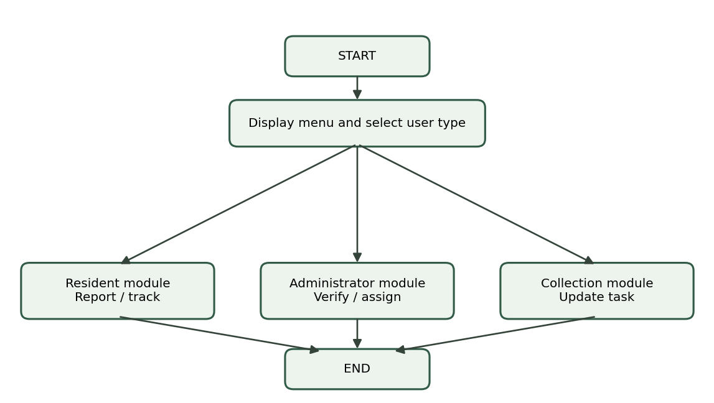

6.2 Waste Reporting Flowchart
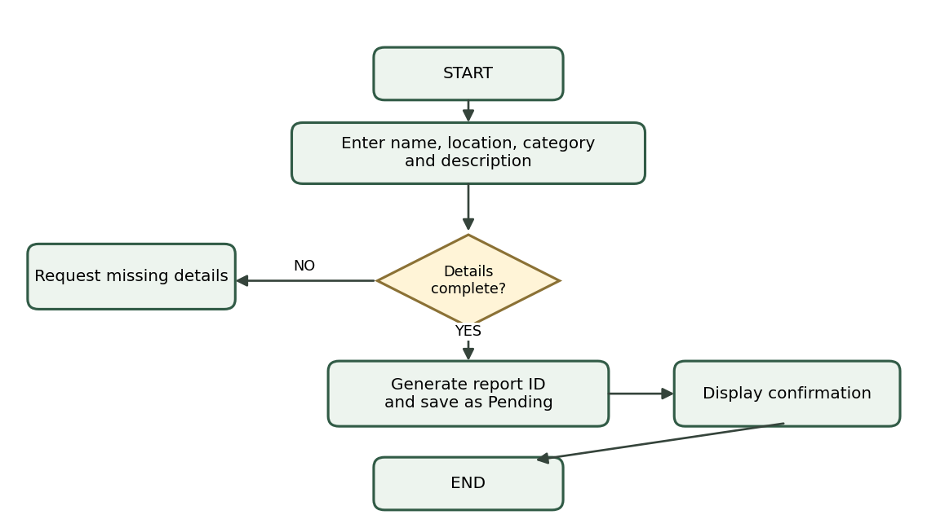

6.3 Administrator Flowchart
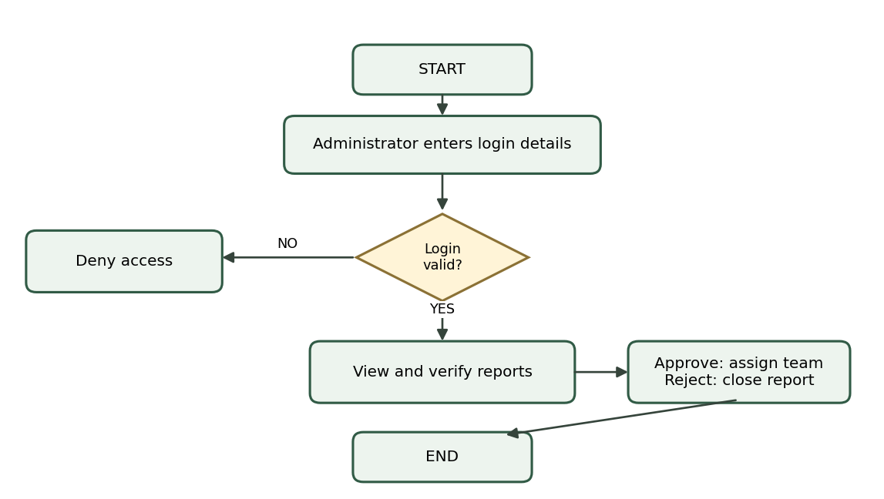

6.4 Collection Team Flowchart
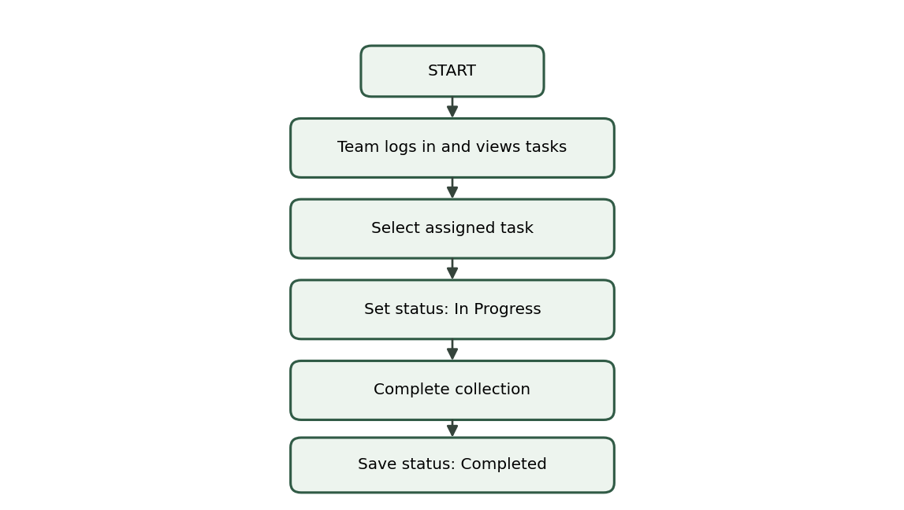

7. SYSTEM MODULES AND FUNCTIONS
Module | Purpose
Resident | Submit reports and track status.
Administrator | Verify reports and assign collection teams.
Collection | View assigned tasks and update progress.
Tracking | Find a report using its reference number.
Reporting | Prepare summaries for administrators.

A modular design makes the system easier to understand, test, maintain and improve. Each module performs a specific task and shares relevant information with other modules.

8. VARIABLES, DATA TYPES AND CONTROL STRUCTURES

8.1 Variables and Data Types
Variable | Data type | Purpose
resident_name | String | Resident's name.
location | String | Waste location.
report_ID | Integer | Identifies a report.
waste_category | String | Waste type.
status | String | Report progress.
choice | Integer | Menu selection.

8.2 Control Structures
Structure | Use
Sequence | Perform instructions in order.
Selection | IF/ELSE approves, rejects or requests corrections.
Repetition | FOR EACH processes multiple reports or tasks.
Boolean logic | AND/OR combine validation conditions.

9. EXPECTED SYSTEM OUTPUTS
- Submission confirmation and unique report ID.
- Verification and collection assignment status.
- Collection progress and completion updates.
- Administrative summaries of pending, approved, rejected and completed reports.
Example: Report ID 10025 | Status: Pending Verification | Message: Your waste report has been submitted successfully.

10. GITHUB AND OPEN-SOURCE SOFTWARE

11. DIGITAL PUBLIC GOODS AND SDG ALIGNMENT
Digital Public Goods are digital solutions that provide public benefit and meet requirements such as open licensing, privacy, security, accessibility and documentation. SWMS could support this idea if it is developed and released in a way that meets the Digital Public Goods Standard.
Goal | Connection to SWMS
SDG 11 – Sustainable Cities and Communities | Supports cleaner and more sustainable communities.
SDG 12 – Responsible Consumption and Production | Encourages improved waste handling and responsible disposal.
SDG 3 – Good Health and Well-being | May help reduce environmental conditions associated with health risks.

12. CONCLUSION
The Smart Waste Management System (SWMS) is a proposed digital solution designed to address some of the waste management challenges affecting communities in Freetown, Sierra Leone. The project focuses on improving the way residents report waste problems, how administrators manage submitted reports and how collection teams receive and update their assigned tasks. By introducing a more organized reporting and monitoring process, the proposed system can help improve communication, coordination and accountability in waste collection activities.
Throughout this project, computational thinking concepts such as decomposition, pattern recognition, abstraction and algorithm design have been applied to explain how the system can operate. The problem was divided into smaller sections, including resident reporting, administrator verification, collection team assignment and report tracking. Algorithms and pseudocode were also developed to demonstrate the logical steps involved in processing reports and updating their status. Flowcharts were included to provide a visual representation of the system's processes and decision-making activities.
The project also demonstrates the importance of programming concepts such as variables, data types, sequence, selection, repetition and Boolean logic. These concepts help explain how information would be collected, processed, stored and managed within the proposed system. In addition, GitHub provides a platform for organizing the assignment documents, storing the diagrams and maintaining a record of changes through commit history.
In conclusion, the Smart Waste Management System demonstrates how technology and logical problem-solving can be used to address a real-life environmental challenge in Sierra Leone. Although this assignment focuses on the logical design rather than the development of a complete software application, the proposed system provides a foundation for future development. If implemented, it could help make waste reporting more accessible, improve collection coordination and support the creation of cleaner and healthier communities in Freetown.

13. REFERENCES
- Digital Public Goods Alliance. (n.d.). Digital Public Goods Standard. https://digitalpublicgoods.net/
- GitHub. (n.d.). GitHub Documentation. https://docs.github.com/
- Open Source Initiative. (n.d.). The Open Source Definition. https://opensource.org/osd
- United Nations. (n.d.). Sustainable Development Goals. https://sdgs.un.org/goals
- United Nations Environment Programme. (n.d.). Waste management. https://www.unep.org/

